Lahore Garrison University
DHA Phase 6 Lahore



Student Name | Muneeb Ur Rehman
Student Roll No | Fa-2023-BSCS-490
Section | D
Subject | Web Technology
Instructor Name | Mr. Muhammad Yousaf

Lab 4: Forms & Multimedia

Lab 4: Forms & Multimedia — Step-by-Step Solution

Objectives Recap
- Create an accessible HTML feedback form.
- Embed audio and video.
- Use <canvas> for basic static drawing.

Tools Required
- VS Code (code editor)
- Live Server (for preview)
- W3C Validator (for form validation)

Step 1: Create the HTML Structure
<!DOCTYPE html>
<html lang="en">
<head><meta charset="UTF-8"><title>Feedback</title></head>
<body>
<h1>Feedback Form</h1>
<form action="#" method="post">
<input type="text" name="name" placeholder="Name" required>
<input type="email" name="email" placeholder="Email" required><br>
Gender: <label><input type="radio" name="gender" value="male">M</label>
<label><input type="radio" name="gender" value="female">F</label><br>
Interests: <label><input type="checkbox" name="interest" value="coding">C</label>
<label><input type="checkbox" name="interest" value="design">D</label><br>
<select name="experience">
<option value="">Experience</option>
<option value="beginner">Beginner</option>
<option value="intermediate">Intermediate</option>
<option value="advanced">Advanced</option>
</select><br>
<textarea name="comments" rows="3" placeholder="Feedback"></textarea><br>
<input type="submit" value="Submit">
</form>
</body>
</html>

Step 2: Embed Audio and Video
<h2>Multimedia Demo</h2>
<audio controls src="sample-audio.mp3">Your browser does not support audio.</audio>
<video width="320" height="240" controls src="sample-video.mp4">Your browser does not support video.</video>

Step 3: Add Canvas Drawing
<canvas id="c" width="200" height="100" style="border:1px solid#000"></canvas>
<script>c.getContext("2d").fillStyle="#F00";c.getContext("2d").fillRect(20,20,150,50);</script>

Final Deliverables
• feedback-form.html with:
- Accessible form (labels, placeholders, validation)
- Embedded audio and video o Canvas with static drawing

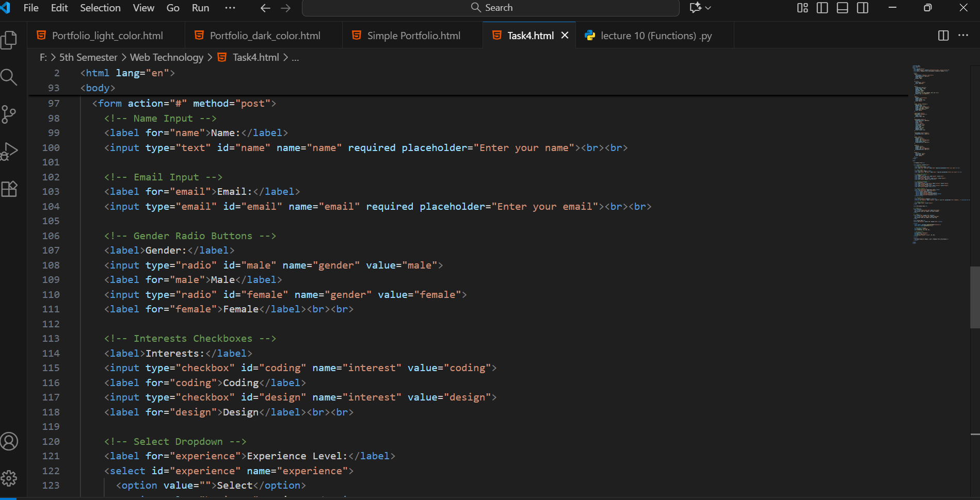
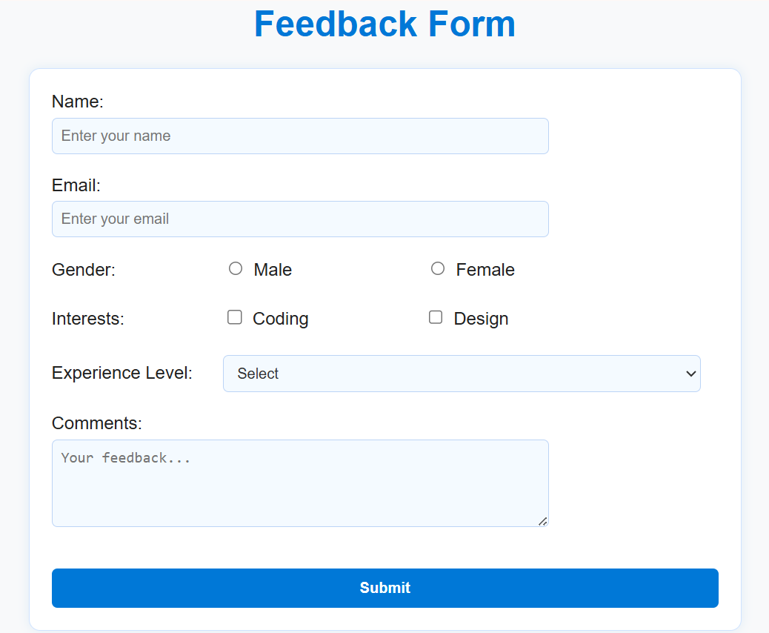

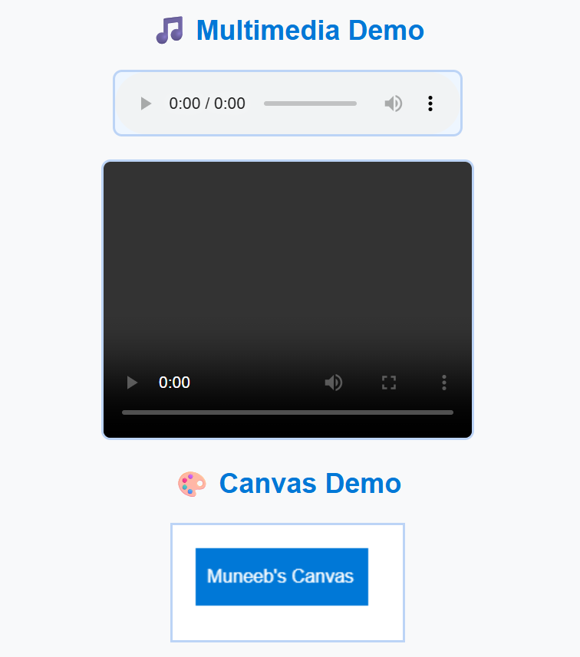

CONCLUSION:
________________________________________________________
________________________________________________________
________________________________________________________
________________________________________________________

RUBRICS:

Performance |  |  |  | Lab Report
Description | Total  Marks | Marks Obtained | Description | Total  Marks | Marks Obtained
Ability to  Conduct practical | 5 |  | Structure | 5
Data Analysis & Interpretation | 5 |  | Efficiency | 5
Total Marks obtained |  |  | Total Marks Obtained

Instructor Signature

